Tasks SQL

Task1

A-

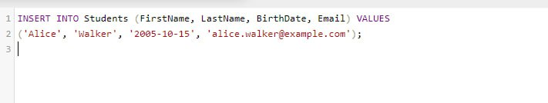

Output

B-2

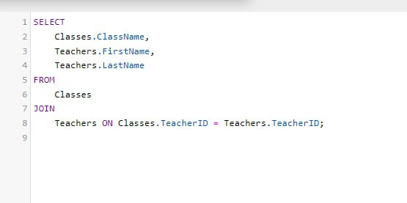

Output

c-

Output

------------------------------------

Task-2

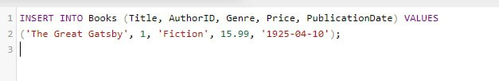

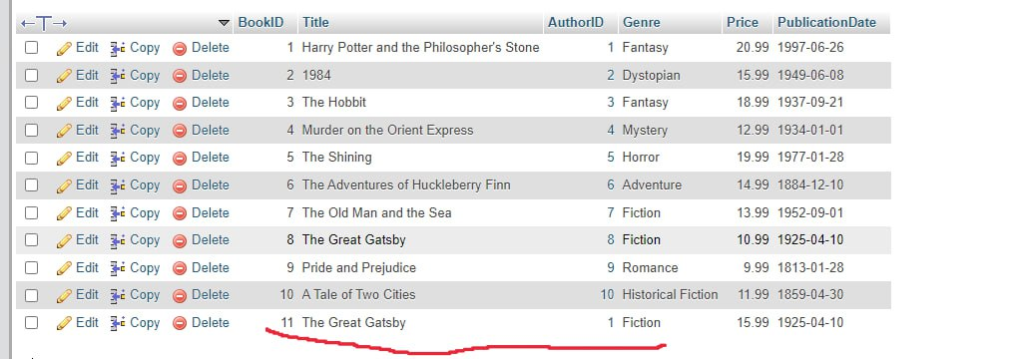

B-

c-

2-4

2-5

2-6

2-7

2-8

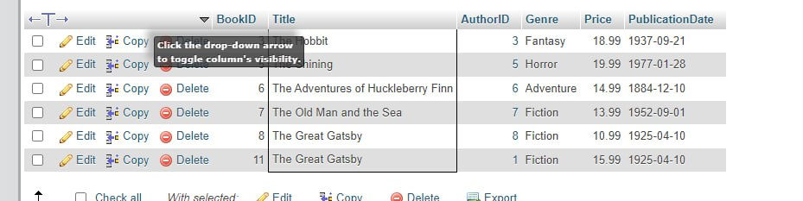

2-9

2-10

------------------Task 3 --------------------

3-1

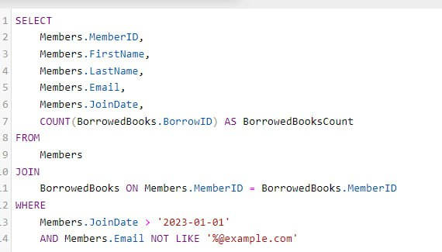

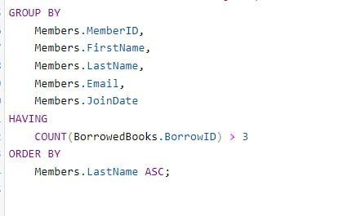

output



----------------------------TASK 4--------------------------------

4-1

4-2

4-3



4-4

4-5

